Top of Form

* + [**Profile**](https://techsupport.kofax.com/profile/)
  + [**Change Password**](https://techsupport.kofax.com/profile/change-password/)
  + [**Sign Out**](https://techsupport.kofax.com/account-signout?returnUrl=%2Fknowledge-base%2F13452)

Top of Form

**Kofax Analytics for Capture - KAFC 1.2.x DB Connection Maintenance**

* [Portal Knowledge Base](https://techsupport.kofax.com/knowledge-base/) / 13452

**Summary**

**Applies to**:  KAFC 1.2.x  
**Date**:  April 12, 2016

**Summary**:  This article will describe where the main database (DB) connections for the KAFC 1.2.x solution can be accessed and maintained.

**Introduction**

During the normal course of business, it may at some point become necessary to change the names, locations, and/or credentials used for connecting to the four main DB’s that KAFC 1.2.x uses.  As a general rule of thumb, anytime you change the details of a DB connection, you will need to update those connection details anywhere you have saved them in your application(s).

One common scenario where this can come about is if these DB’s are moved/migrated to some new infrastructure as part of a hardware and/or DBMS software upgrade.

Since these DB connections are often not touched after initial installation or prior upgrade, it may be hard to recall where these key DB connections are maintained.  
  
NOTE:  Please note that this KB Article does not relate to new or empty DB's, as could be encountered during some installation or Project creation scenario.  Please refer to your standard KAFC and Insight documentation for details on creating or initializing empty DB's.  This KB Article only relates to non-empty databases for existing KAFC environments and Projects.

**Maintaining DB Connections for KAFC 1.2.x**

KAFC 1.2.x is comprised of four main DB’s:  *kafc_admin*, *kafc_meta*, *kafc_data*, and *kafc_staging* (your actual names may be different).  The connection details for these DB’s are maintained in the following places, and in the following recommended order for changing:

**Insight Installation Manager** - standalone exe tool  
*kafc_admin*  
  
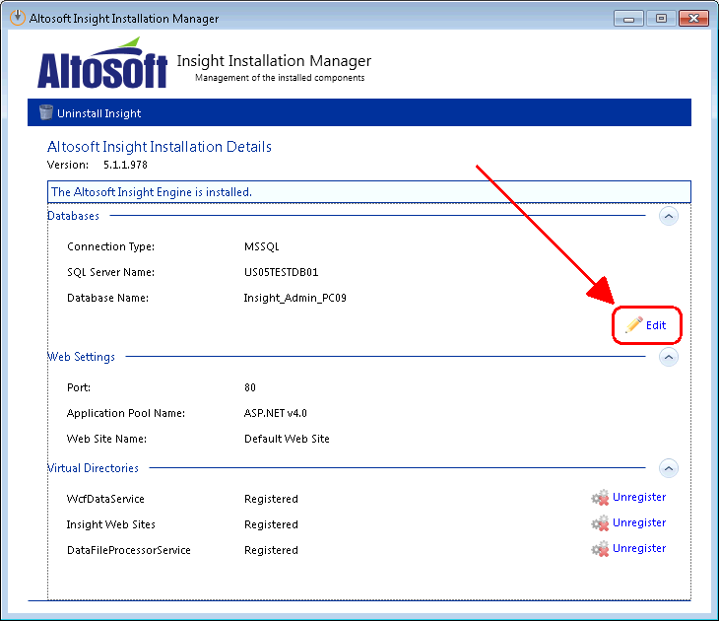

After clicking *Edit,* you will get the following screen where you can modify the connection settings for *kafc_admin* DB.  Be sure that the *Use Existing Database* option is selected; otherwise the DB will be re-initialized (deleted and re-created).  
  
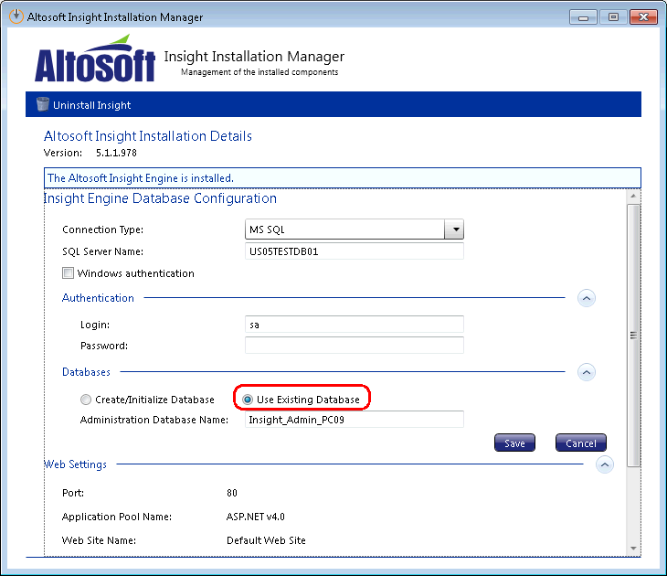

**Insight Admin** - web app  
        *kafc_meta*  
*kafc_data*  
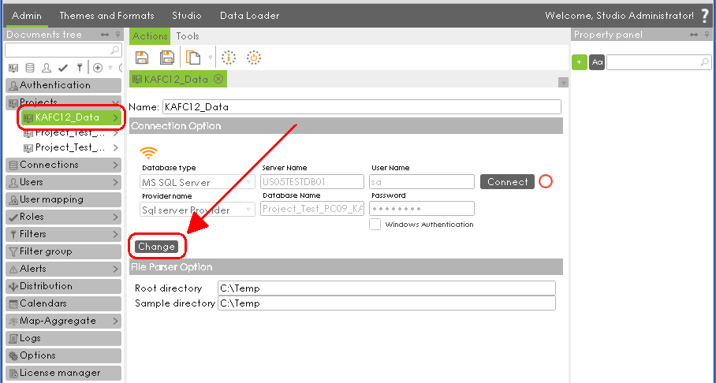After clicking *Change,* you will get the following screen where you can modify the connection settings for *kafc_meta* and *kafc_data* DB’s.

Be sure that the *Add Existing* tab is selected, otherwise your DB’s will be re-initialized (deleted and re-created).  
  
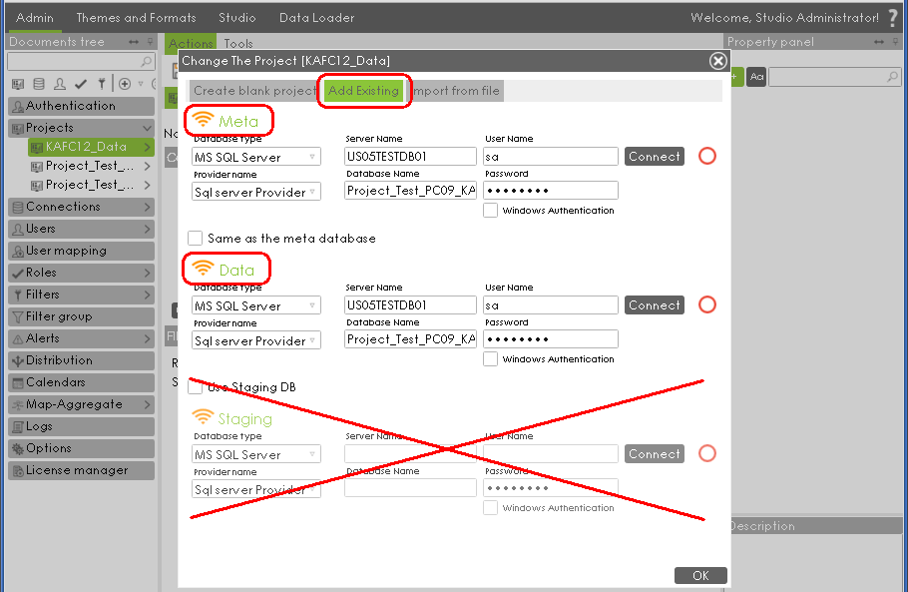

**Insight Studio** - web app  
        “Data DB” Data Source (*kafc_data*) must be confirmed.  
  
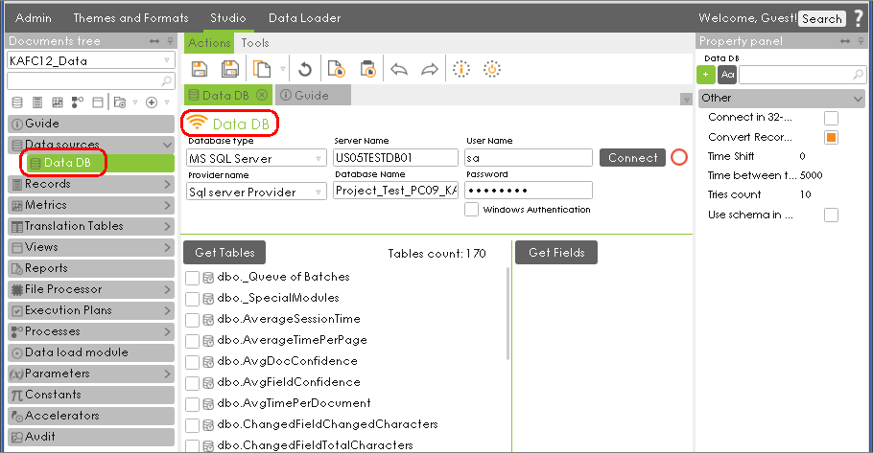

**Listener Web Agent** - this web app must be re-installed in order to change DB connections.  
*kafc_staging*  
*kafc_data  
  
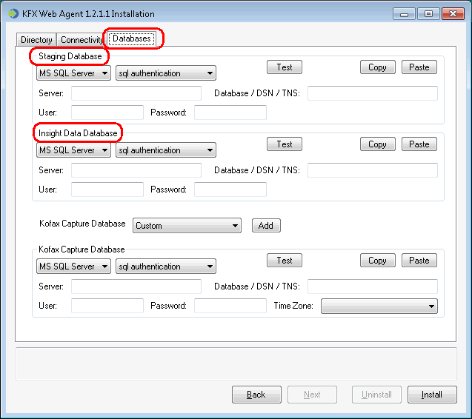*NOTE: Some additional considerations for the **Listener Web Agent** (since it must be re-installed):

* During installation, be sure to use the correct *User* and *Password* for Analytics WFA Connectivity (see screenshot below); otherwise the existing WFA’s will not be able to connect to the newly-installed Listener.
* Also note that the **Listener Web Agent** connects to the Kofax Capture DB, but that DB is considered part of the Capture system (which is often on a separate DB Server) and is not directly discussed here.  Correct connection details must be entered for this DB as well due to re-installation process.

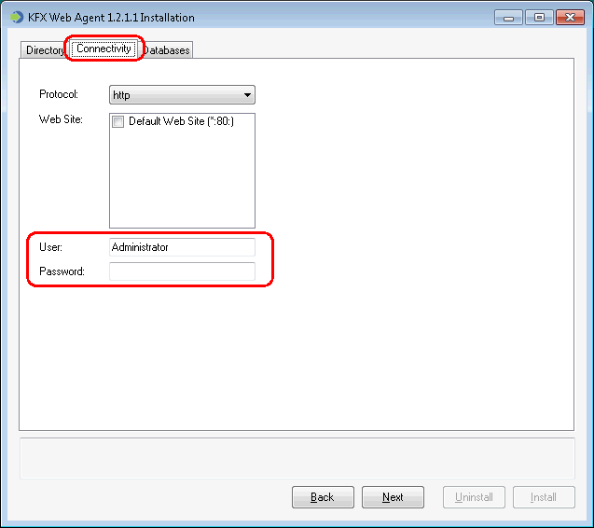  
 **Additional Notes**

It is strongly recommended to make sure all new DB connections are changed, tested, and everything is verified to be working correctly on the “new” DB server before disabling the “old” DB server.  If the “old” DB server is disabled first, you will not be able to log in to **Insight Installation Manager** and a re-install of Insight would need to be performed (this can be done by launching the **Insight Installation Manager** from the command line with an added “/i” parameter).  
  
  
**Related KB Articles  
  
13453**: Kofax Insight - DB Connection Maintenance

Bottom of Form